Adobe Acrobat Reader – Correct Versions and Configuration

- New Adobe Acrobat Reader DC 15.9

We are pleased to inform you that the first tests we have done with the latest version 15.9 of Acrobat Reader DC published on the 13/10/2015 show that it indeed resolves the blocking bugs produced by Acrobat Reader DC 15.8 (published on 14/07/2015). Consequently, all users can start installing the latest 15.9 version with the PDF e-Forms. The old Acrobat Reader DC 15.8 must not be used and it continues to be blocked on the new PDF e-Forms released.

- New security feature introduced in the Acrobat Reader DC 15.9:

When the user will use Acrobat Reader DC 15.9 for the first time with PDF eForms which is not stored in an already trusted folder, Acrobat Reader will prompt a new security question asking if the user trust the "europa.eu" domain (it could happen on Check PIC, on budget change or on submission). It is mandatory that the user answer "Allow" to trust Europa.eu so that the forms can work properly.

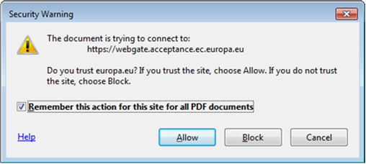

If by mistake the user answers Block on the "europa.eu" domain the properties are saved locally inside Acrobat Reader DC and are applied for all PDF forms.

The first screen the user will receive (without a Yellow security bar) is the following one meaning that 1 of the many security features is preventing the forms to execute properly:

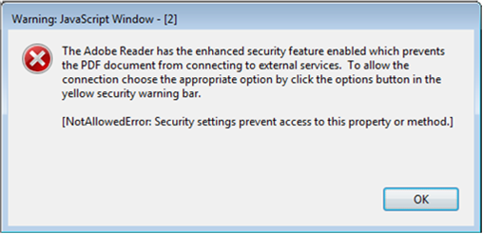

The way to revert this blockage is to go to the Acrobat Reader DC properties and to allow "Europa.eu":

Menu "Edit" -> "Preferences…" or Ctrl + K

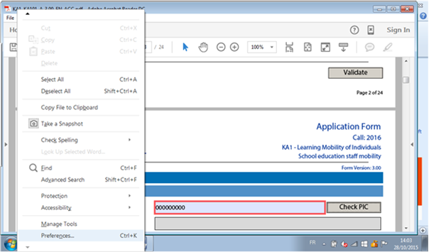

Categories: "Trust Manager" and "change Settings…" button:

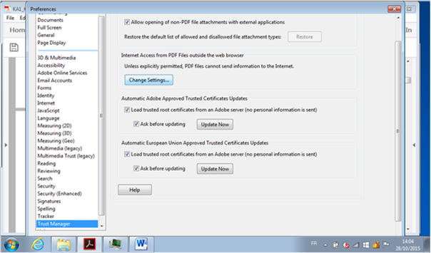

Please note that the categories "Internet", "Security" and "Security (Enhanced)" contain some options which could also block the form to access to internet:

In the Web Sites table, select the row "Europa.eu" "Always Block" and click on "Delete" button:

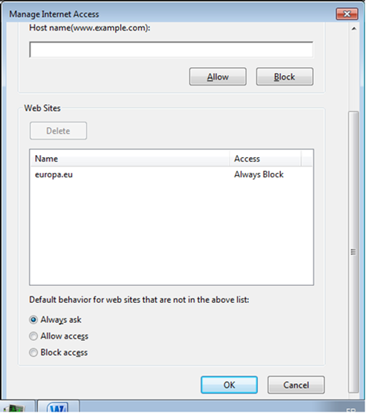

Finally click on "OK" buttons to apply the change and close all properties windows.

After that, the user will try again to access to e-Forms server on "Europa.eu", the same "Security Warning" will appear and the user has to answer "Allow".

Another way to unblock the PDF e-Forms is to use the option to trust a file/folder:

Categories: Security (Enhanced) and buttons "Add File" or "Add Folder Path"

